**SUCCESS INTEGRATED NURSERY SCHOOL**

**Internal End of First Term Examinations 2020**

**English 5-6 years**

Name _____________________________Stream____________

1. **Listen and write.**

a) ______________________ b) ___________________

c) ______________________ d) ____________________

e) __________________________

2. **Fill in the missing letters.**

a b ____d e f ____h i

j k l ___ n o ___ q r

____ t u v ___ x y z

3. **Name the pictures.**

|  |  |  |  |  |
| --- | --- | --- | --- | --- |
| [https://encrypted-tbn2.gstatic.com/images?q=tbn:ANd9GcSv85LBu-lb9xeqQvnVy7ppbcZZ9dy82vYilxwTlKBLy57vaVcv57HqRxM](http://www.google.com/url?url=http://pseventrentals.com/shop-by/chairs/chiavari-chairs/blac-chiavari-chair-2/&rct=j&frm=1&q=&esrc=s&sa=U&ved=0CCQQwW4wBjgoahUKEwiM36nNm6PIAhWKPRoKHarSCds&usg=AFQjCNH03ja5xm7emgfFgTns4bMKZoK7YA) | [https://encrypted-tbn1.gstatic.com/images?q=tbn:ANd9GcTGMJd3I3HfNqWl2j9GJz2jklgKSnS_968Y7DQr_SfaNibj7CER20Gnhno](http://www.google.com/url?url=http://www.clipartsheep.com/table-clipart/dT1hSFIwY0RvdkwyVjBZeTUxYzJZdVpXUjFMMk5zYVhCaGNuUXZORGN3TUM4ME56YzVMM1JoWW14bFh6RmZiR2N1WjJsbXx3PTEwMjR8aD02MDR8dD1naWZ8/&rct=j&frm=1&q=&esrc=s&sa=U&ved=0CCwQwW4wCmoVChMI_IiRua2RxwIVrW7bCh2y0Afx&usg=AFQjCNGtjFM5uACSctAQ3A5ZyGlNlPLD_Q) | [http://t1.gstatic.com/images?q=tbn:ANd9GcT4og6zMC2VV6wbpOXOOrJM9MgzViFz9LTVO5COPloxlCPbuL7lSTRbeGchttp://t1.gstatic.com/images?q=tbn:ANd9GcT4og6zMC2VV6wbpOXOOrJM9MgzViFz9LTVO5COPloxlCPbuL7lSTRbeGc](http://www.google.com/imgres?imgurl=http://openclipart.org/people/cyberscooty/1344005788.svg&imgrefurl=http://openclipart.org/detail/171437/stylieed-book-by-cyberscooty-171437&usg=__YdjgukI3TeQiUJyy5p7_Tj2WAMI=&h=471&w=699&sz=7&hl=en&start=54&zoom=1&tbnid=OzuFH35MM4Hy6M:&tbnh=94&tbnw=139&ei=y5rvUaXkBeam0AXfqIHwBQ&prev=/search?q=books&start=40&sa=N&hl=en&sout=1&biw=1341&bih=555&site=imghp&tbs=itp:clipart&tbm=isch&itbs=1&sa=X&ved=0CEgQrQMwDTgo) | [https://encrypted-tbn1.gstatic.com/images?q=tbn:ANd9GcROpQf_Z1949qgBbNTsXCV6vMgeU6MxVpfya-bBmEscspbY_4n67y0KK5A](https://www.google.com/url?q=http://avteqliving.com/shop/single-bunkable-beds/&sa=U&ei=B8o3VMLTGcTWaoyigaAO&ved=0CCYQ9QEwBzgo&usg=AFQjCNFBj98QS6Gi9-rlzsCYClFUo7mwlA) | https://encrypted-tbn1.gstatic.com/images?q=tbn:ANd9GcR3LlKn3J2FLJtmBxNXOmvO8j77i8Z5PkjZ0eJAap2mzx0AL_jPyQ |
|  |  |  |  |  |

4. **Write in capital letters.**

d u c k b e d f a n

5. **Write words correctly.**

lgir ___________________ lstoo _________________

tma __________________ obko ________________

[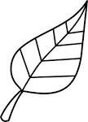](http://www.google.com/imgres?imgurl=http://sweetclipart.com/multisite/sweetclipart/files/nature_seasons_leaf_spring_or_autumn_lineart.png&imgrefurl=http://sweetclipart.com/colorable-line-art-leaf-386&usg=__HKwOsswgVWLYgiRUUlznAEd6lgA=&h=5176&w=3734&sz=268&hl=en&start=30&zoom=1&tbnid=srMpyKfZX45iLM:&tbnh=150&tbnw=108&ei=v3SEUsfIH8rYtAaNsoHICg&itbs=1&sa=X&ved=0CEAQrQMwCTgU)6. **Underline the correct word for the picture.**

lfea leaf fael

[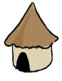](http://www.google.co.ug/imgres?q=hut&hl=en&biw=1366&bih=535&tbs=itp:clipart&tbm=isch&tbnid=qC2hcrIXmoUgzM:&imgrefurl=http://www.friendsofguinea.org/myletters.shtml&docid=QDFyToreHY2kLM&imgurl=http://www.friendsofguinea.org/cartoons/hut.gif&w=467&h=458&ei=9rKXUPeeIcrLtAbJtIDoAw&zoom=1&iact=hc&vpx=106&vpy=20&dur=812&hovh=222&hovw=227&tx=135&ty=114&sig=114549910144603029910&page=2&tbnh=155&tbnw=162&start=14&ndsp=18&ved=1t:429,r:12,s:14,i:221)

hut hat htu

[](https://www.google.com/url?q=http://www.clker.com/clipart-pencil-6.html&sa=U&ei=yW46U6TGGIfPtQbm7oGYCg&ved=0CDwQ9QEwBjgU&usg=AFQjCNFd2s3f3e_-Eewx1HWJ2Kg1E-SdYA)

pincel pecnil pencil

[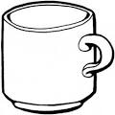](http://www.google.com/imgres?imgurl=http://www.supercoloring.com/wp-content/main/2009_09/Coffee-cup-coloring-page.gif&imgrefurl=http://www.supercoloring.com/pages/coffee-cup/&usg=__YoWPXBVRVLPu4kqTK6UDT8XRoNg=&h=350&w=351&sz=33&hl=en&start=1&zoom=1&tbnid=dtDgh1MMvUd5HM:&tbnh=120&tbnw=120&ei=VIfvUaDdB9KwhAeg4IHoAQ&prev=/search?q=cups&sa=X&hl=en&sout=1&biw=1341&bih=555&site=imghp&tbs=itp:lineart&tbm=isch&itbs=1&sa=X&ved=0CC4QrQMwAA)

mug umg mgu

[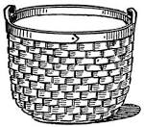](http://www.google.com/url?url=http://etc.usf.edu/clipart/3800/3870/basket_1.htm&rct=j&frm=1&q=&esrc=s&sa=U&ved=0CCwQwW4wCmoVChMI8KDKhuDzyAIVAVcUCh3Z-Q1_&usg=AFQjCNFJJTYatIbsY7dFE0iUl19uONm_BA)

beskat basket bskeat

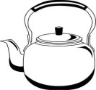7. **Match pictures to words.**

boxes

[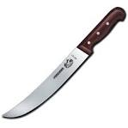](https://www.google.com/url?q=http://www.swissknifeshop.com/shop/swiss-army/victorinox/victorinox-cutlery/butcher-cimeter-knives&sa=U&ei=VegWU6nNBtDx0wH2koGwCw&ved=0CEQQ9QEwCjgU&usg=AFQjCNFpI5ziSVuJL-igvdoosiJbM-LEKQ)

bucket

[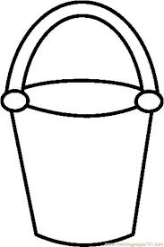](http://www.google.com/imgres?imgurl=http://www.coloringpages101.com/coloring_pages/Seasons/sandpailBW_qjoom.jpg&imgrefurl=http://printablecolouringpages.co.uk/?s=+and+pail&h=900&w=601&tbnid=AIfUK2SGIUCQaM:&zoom=1&docid=n0qW6XYbR2E52M&hl=en&ei=w7wTVYb9LpL1aIqtgIAN&tbm=isch&ved=0CEIQMyg6MDo4ZA)

kettle

knife

8. **Fill in the missing letters.**

cl___ck dres___ t___n

9. **Read and draw.**

|  |  |  |  |  |  |
| --- | --- | --- | --- | --- | --- |
| Here is a mat. | | I can see a ball. | | I can see two boys. | |
| television | flower | | trees | | cat |

[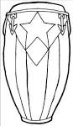](https://www.google.com/url?q=http://mavericktears.deviantart.com/art/Peurto-Rican-Conga-Drum-Clean-Line-398209713&sa=U&ei=J8QVU9TjDcSW2AWr4YCABQ&ved=0CFQQ9QEwEjjUAg&usg=AFQjCNFhQ2ACai4X-A7M95MyU80qCs2Sog)10. **Make sentences.**

a) It is a drum.

http://www.coloringpages101.com/coloring_pages/Kitchenware/Cupandsaucer_nyzhv.jpg

b) _____________________________________________

[](https://www.google.com/url?q=http://www.tropical-plants-flowers-and-decor.com/sun-clip-art.html&sa=U&ei=iBIyVOmnIZTvasu-gJgG&ved=0CDQQ9QEwDg&usg=AFQjCNEiNqQtgypPCHK8EyzzvZ089nE5Pg)

c) _____________________________________________

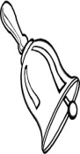  
 d) _____________________________________________

[Image result for axe](http://www.google.com/url?url=http://www.clipartsheep.com/battle-axe-stuck-in-a-white-surface-vector-illustration-clipart/dT1hSFIwY0RvdkwyTmtiaTU0YkM1MGFIVnRZbk11WTJGdWMzUnZZMnR3YUc5MGJ5NWpiMjB2WTJGdWMzUnZZMnN4T1Rnek1UVTBOUzVxY0djfHc9MjQ0fGg9MTk0fHQ9anBlZ3w/&rct=j&frm=1&q=&esrc=s&sa=U&ved=0CDwQwW4wEjhQahUKEwjZwoDkqfTIAhWCShQKHXYdCCQ&usg=AFQjCNHrBuHSHs66DUeJ15Maub6xTcEA7g)

e) _____________________________________________

11. **Complete the sentences.**

a) I have _______________ eyes.

b) I am _____________ years old.

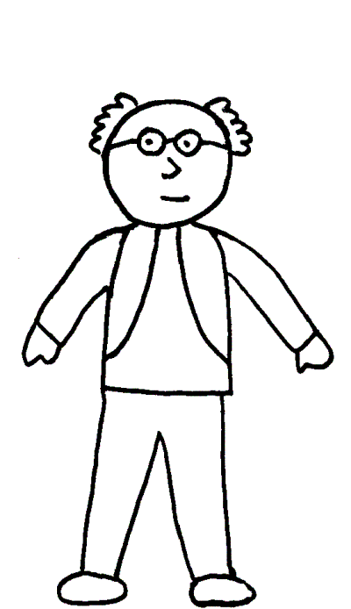 c) Tom and Sam have _________________ legs.

d) I can see six ____________